Equation of a Straight line, 3d plane and Hyperplane (n Dimension):

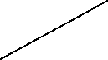

Equation of a straight line:

y = mx + c

Where,

m = slope (In unit movement in the x axis, what is the unit movement in the y axis)

c = intercept

Other notations:

y = $β_{0}+ β_{1}x$

ax + by + c = 0

Operating,

by + c = -ax

by = -ax -c

y = $-\frac{ax}{b }- \frac{c}{b}$

Multiple dimensions:

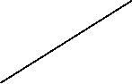

Equation of the straight line:

$w_{1}x_{1}+ w_{2}x_{2}+ b=0$

Where w1 and w2 are coefficients

Equation of a straight line: $W^{T}X+b=0$

For three dimensions or axes:

We will not draw a straight line instead we will draw a 3d plane

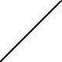

, Where

W = $\left[\begin{matrix}w_{1} \\ w_{2} \\ w_{3}\end{matrix}\right]$, X = $\left[\begin{matrix}x_{1} \\ x_{2} \\ x_{3}\end{matrix}\right]$

For n dimensional plane:

$w_{1}x_{1}+ w_{2}x_{2} + w_{3}x_{3}+…+ w_{n}x_{n}+b=0$

$W^{T}X+b=0$

Equation of a straight line passing through the origin:

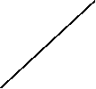

b = 0

$w_{1}x_{1}+ w_{2}x_{2}=0$

$=0$

Equation of a plane is given by the notation pi

Equation of a plane = $π_{n}$: $W^{T}X=0$, since we have considered our line is passing through the origin

W = $\left[\begin{matrix}w_{1} \\ w_{2} \\ w_{3} \\ … \\ w_{n}\end{matrix}\right]$, X =

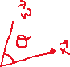

w.x = $W^{T}X$ = $\left|w\right|\left|x\right| cosθ$ = 0

$cosθ$ = 0, when

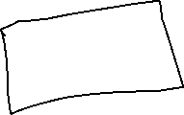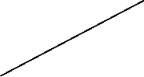

Conclusion: W will always be perpendicular to the plane